Jesus: The 'original hipster'?
That's the new message from the Catholic diocese of, yup, Brooklyn.
By Peter Weber | April 26, 2013
http://theweek.com/article/index/243371/jesus-the-original-hipster
http://news.yahoo.com/jesus-original-hipster-121300093.html
Hipster: A person who is unusually aware of and interested in new and unconventional patterns. The quality or state of being hip. Having or showing awareness of or involvement in the newest developments or styles, i.e.: chic, cool, vogish.
Note: My question is how low will you go to try and proselytize someone to your false faith? Well, the Roman Catholic "church" is willing to blasphemy (blasphemy: the act of insulting or showing contempt or lack of reverence for God) the Son of God, the Lord Jesus Christ of Nazareth, in an effort to bring people to their false faith.
As I've explained before, the Roman Catholic "church," this mystery religion a man made made up religion of the Jews (Judaizers) experiences with their false worship in Egypt, Babylon, their Baal worship, and pagan Roman worship, and came up with the satanic "oral law" of the Talmud and their black magic Kabbalah; their worship of Mary as a co-savior, their worship of idols they simply rename as icons to confuse poor lost souls, their worship of the 'pope' as infallible as a God who is supposed to be able to forgive sins, mixed it with Christianity to create their evil, satanic mystery religion.
www.alemattec.com/The satanic Jewish Talmud, and the Roman Catholic 'church' . . . .doc
www.alemattec.com/Kabbalah, black magic. The Jewish Talmud teaches that Jesus was sent to hell, where he is punished by boiling excrement for mocking the Rabbis . . . .doc
The Jews did the same thing. They had been divorced by God for their evil, and had been caste out of their land not once, but twice for their false worship.
Note: God uses His own Law to divorce Israel: Deuteronomy 24:1-4, Isaiah 50:1, Jeremiah 3:8, www.alemattec.com/What did Jesus REALLY say concerning divorce - Matthew 5-31 and32.doc The Lord Jesus Christ of Nazareth appears, the Son of God, their Messiah, and they were so darkened by their sin that they didn't know the time of the visitation, and thus the Lord Jesus Christ of Nazareth curses them repeatedly, attacking their leadership and their now false priesthood, as they were merely actors, hypocrites.
Matthew 23:13-15
13 But woe unto you, scribes and Pharisees, hypocrites! for ye shut up the kingdom of heaven against men: for ye neither go in yourselves, neither suffer ye them that are entering to go in.
Note: Woe in the Greek means: woe!, alas!, uttered in grief or denunciation. Uttered in grief and used as a public condemnation, publicly judging and condemning. Stating their were judged and condemned by God, a curse upon them, cursed of God.
14 Woe unto you, scribes and Pharisees, hypocrites! for ye devour widows' houses, and for a pretence make long prayer: therefore ye shall receive the greater damnation.
15 Woe unto you, scribes and Pharisees, hypocrites! for ye compass sea and land to make one proselyte, and when he is made, ye make him twofold more the child of hell than yourselves
Note: The Jews had so distorted Judaism, by having brought in and mixed their false Egyptian worship, their Babylon worship, and their Baal worship with Judaism, that the Lord Jesus Christ of Nazareth says they were cursed of God. The Scribes and Pharisees were hypocrites! Hypocrite in the Greek means actor. The Lord Jesus Christ said the leaders of Judaism were actors. They had been teaching for centuries a false religion. Furthermore, the Lord Jesus Christ of Nazareth says the Jews would " . . . compass sea and land to make one proselyte, . . ." The Jews would compass (compass in the Greek means: go about, lead about, traverse (traverse means: to deny (as an allegation of fact or an indictment) formally at law.
The Jews, their leaders, the Scribes and Pharisees who had been teaching for centuries false instruction denying God's Law in order to make one proselyte. (Proselyte in the Greek means: A non-Jew, who has been circumcised and has adopted the Jews' religion. A convert to Judaism).
This is absolutely no different from the Roman Catholic "churches" leadership today (that came from these evil Jews) as they do exactly the same thing. The Roman Catholic "church" has for centuries given false instruction, denying God's Law in order to make proselytes.
2 Timothy 3:5
5Having a form of godliness, but denying the power thereof: from such turn away.
Titus 1:16
16They profess that they know God; but in works they deny him, being abominable, and disobedient, and unto every good work reprobate.
Note: Reprobate in the Greek means: Failing to pass the test, unapproved, counterfeit. In all their "good works" thinking they are making themselves right with God, they fail. They flunk the test. They are unapproved by God, as they are false worshipers, counterfeit.
Jude 1:4
4For there are certain men crept in unawares, who were before of old ordained to this condemnation, ungodly men, turning the grace of our God into lasciviousness, and denying the only Lord God, and our Lord Jesus Christ.
Note: Lasciviousness in the Greek means: wantonness, lewdness, outrageous conduct, conduct shocking to public decency, a wanton violence.
Jude 1:13
13Raging waves of the sea, foaming out their own shame; wandering stars, to whom is reserved the blackness of darkness for ever.
Note: These false worshipers, the Roman Catholic "church," crept in unawares into Christianity dragging their false worship learned in Egypt, Babylon, worshiping Baal, and their pagan Roman worship, mixed it with Christianity, these Judaizers made their mystery religion and thus denying the only Lord God, and our Lord Jesus Christ by their outrageous conduct, conduct shocking to public decency. They are raging waves of the seam, foaming out their own shame, false Preachers (stars), to whom God has reserved the blackness of darkness for them forever.
Here is their outrageous conduct, shocking to public decency of any True Worshiper, one Born Again, the Elect of God:
It's a well-documented phenomenon that younger Americans are abandoning organized religion in droves, and that the Roman Catholic Church would be graying alongside its mainline Protestant brethren were it not for immigration. The Diocese of Brooklyn has hit upon a scheme to get the non-immigrant kids back in the pews that's both head-smackingly silly and somehow seemingly inevitable: An ad campaign claiming Jesus Christ was "the original hipster."
It doesn't help that the diocese launched the campaign on April 1 — April Fool's Day. It wasn't until recently, though, that the posters started getting noticed at gyms, bus stops, restaurants, and bars. And it even showed up in that artery of hipsterdom, the L train that shuttles the artfully disheveled between Brooklyn's Williamsburg neighborhood and Manhattan. The most provocative ad is simple: A man in a robe, with red Converse sneakers peeking out:
The main problem with this ad campaign is that while, like pornography, everybody knows a hipster when they see one, nobody really self-identifies as such, making the ad's target audience vanishingly small. But, perhaps to reward the normally staid Catholic Church for trying something new and even daring, the media equivalent of hipsters politely gamed this out.
Maybe Jesus' hipster qualities were revealed in "a really obscure bible verse," says Gawker's Neetzan Zimmerman. "You've probably never heard of it." And obviously, Jesus was "totally into Christianity before it became a religion."
Sure, says Katie McDonough at Salon, and Jesus "was a carpenter, and craftsmanship is big in Brooklyn right now." Not to mention that he famously turned water into wine, "which is very do-it-yourself and kind of locavore-ish, if you think about it." And don't forget the beard. Very hip.
Anna Silman at The New York Observer is mostly confused about what the church is going for here. What's the message? she asks. "The Son of God: He's just like you! He smokes Parliaments! He reads Pitchfork! He rides a fixi!" Sure, the Christian Messiah was grubby and unkempt, but "it's hard to imagine Jesus engaging in his rousing feats of proselytization while still maintaining the requisite nonchalant hipster 'tude."
And hip young observers aren't the only ones agnostic about the ad campaign. The diocese is clearly attempting "culturally engaged evangelization," says Mark Brumley at The Catholic World Report. But "I'm not crazy about a 'Jesus-as-hipster' campaign." It seems like the church is watering down Jesus to avoid offending people, or offering a sort of "Jesus spray" that people will apply lightly, providing "little more than a Jesus-coating of their present lives." If the diocese isn't careful, "we can wind up winning people to a Jesus not worthy of proclaiming in the first place."
So, what is the Brooklyn Diocese thinking? The ads are "geared towards reaching a younger, more diverse demographic by showing the cooler and more welcoming side of the Catholic Church," the diocese says in a press release. Many young people see the church as "archaic and not relevant, nor valuable, to their everyday lives," and the diocese wants them to know they can come as they are.
Every culture represents Jesus as a reflection of itself, and rightly so, says Msgr. Kieran Harrington, the diocesan official who created the campaign with Ruckus Marketing. "Well in Brooklyn, there's a lot of young bohemian type folks." Besides, he tells the New York Daily News, "Why is that an image of Jesus in Converse sneaks so shocking to us?... The Church is countercultural."
This isn't the first time Catholics have reinvented Christ to reach said counterculture. In the 1970s, for example, the Broadway hit Godspell imagined Jesus as a scruffy but handsome hippie type. And hipster isn't such a stretch from there, Brooklyn College religion expert Paul Moses tells the Daily News. "He wasn't ironic, but he was certainly countercultural and spoke the truth no matter what."
As supporting evidence, the diocese points to this April 13 Saturday Night Live segment about young Catholics returning to church because of Pope Francis, with Seth Meyers joking that the reverse exodus is due to the pope's red Chuck Taylors:
Besides, as the old adage goes, there's no such thing as bad publicity. "There's a lot of noise in Brooklyn, lots of people competing for attention," Msgr. Harrington tells the Catholic News Agency. "You have to cut through the noise, and this ad campaign was meant to do that." And it may be working. Since the campaign launched, Harrington says, traffic on the diocese's website has gone up 400 percent.
Revelation 18:2
2 And he cried mightily with a strong voice, saying, Babylon the great is fallen, is fallen, and is become the habitation of devils, and the hold of every foul spirit, and a cage of every unclean and hateful bird.
Revelation 16:15
15 Behold, I come as a thief. Blessed is he that watcheth, and keepeth his garments, lest he walk naked, and they see his shame.
This first picture is title: Jesus, the King of Cool . . .
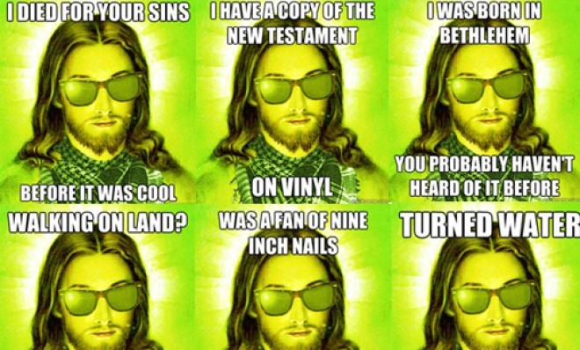

Note: Underground music audiences warmly received Nine Inch Nails in its early years. Reznor produced several highly influential records in the 1990s that achieved widespread popularity: many Nine Inch Nails songs became radio hits;[3] two Nine Inch Nails recordings have won Grammy Awards; and their entire catalog has reached record sales exceeding over 30 million albums worldwide,[4] with 11 million sales certified in the United States alone.[5] In 1997, Reznor appeared in Time magazine's list of the year's most influential people, and Spin magazine described him as "the most vital artist in music."[6] In 2004, Rolling Stone placed Nine Inch Nails at 94 on its list of the 100 greatest artists of all time.[7] – Nine Inch Nails has been nominated for twelve Grammy Awards and won twice for the songs "Wish" and "Happiness in Slavery", in 1992 and 1996 respectively.
http://en.wikipedia.org/wiki/Nine_inch_nails

http://en.wikipedia.org/wiki/Closer_(Nine_Inch_Nails_song)

"Closer" is a song written by Trent Reznor and featured on the 1994 Nine Inch Nails album The Downward Spiral. In mid-1994, the song was released as the second single from the album. Most versions of the single are titled "Closer to God", a rare example in music of a single's title differing from the title of its A-side. ("Closer to God" is also the title of an alternate version of "Closer" featured on the single.) Labeled "Halo 9", the single is the ninth official NIN release.

Several broadcasting stations felt the song was not appropriate to air when uncensored. A promotional single provided by the label to radio stations included both long and short vocal-censored-i.e.: silenced profanity-versions.[1] In spite of the blunt and profane sexual content contained in the song's lyrics, "Closer" became Nine Inch Nails' biggest hit up to that time, cemented Reznor's status as an industrial rock superstar, and remains arguably his best-known song. Heavily edited versions of the song and its equally explicit and provocative Mark Romanek-directed music video received substantial airplay on radio and MTV.

The music video was directed by Mark Romanek and first aired on May 12, 1994, having been filmed in April of that year. It was cut down from its original length to 4:36. The video was infamous and helped bolster the success of the band. The video shows events in what appears to be a 19th century-style mad-scientist's laboratory that deals with religion, sexuality, animal cruelty, politics, and terror. Its imagery was controversial and included:
A nude, bald woman with a crucifix mask.
A monkey tied to a cross.
A severed pig's head spinning on some type of machine.
A diagram of the vulva.
Reznor wearing an S&M mask while swinging in shackles.
Reznor seated in front of a wall covered in fetish gear, wearing a ball gag.

Several times, Reznor, wearing leather pants, floats and rotates through the air, suspended by invisible wires. There are also scenes of Reznor being blown back by a wind machine while wearing aviator goggles.

The unedited version of this video was shown on Playboy TV's music video show Hot Rocks in 1994. In mid-2002, the unedited version of this video was aired on MTV2 as part of a special countdown showcasing the most controversial videos ever to air on MTV. This countdown was only shown late at night due to the graphic imagery of "Closer" and several other videos.

In 2006, "Closer" was voted number one in a VH1 Classic poll titled "20 Greatest Music Videos of All Time." [5]

In retrospect, Reznor commented about the video that "The rarest of things occurred: where the song sounded better to me, seeing it with the video. And it's my song."[6]

The unedited video is included in Closure, The Downward Spiral (DualDisc), Directors Label Volume 4: The Work Of Director Mark Romanek and VEVO, and it is available for download from the United States iTunes Store under the band's page. Behind-the-scenes footage with commentary by Romanek is included in Closure (DVD) and Directors Label.
To illustrate the music video for "Closer", a controversial video due its questionable content, which included, among other things, a crucified monkey (pictured).

Note: If you cannot see the images, and you are using OpenOffice as I am, click on File, Page Preview. You then can adjust the size to 100%, but will need to scrool back and forth, up and down to see the images.
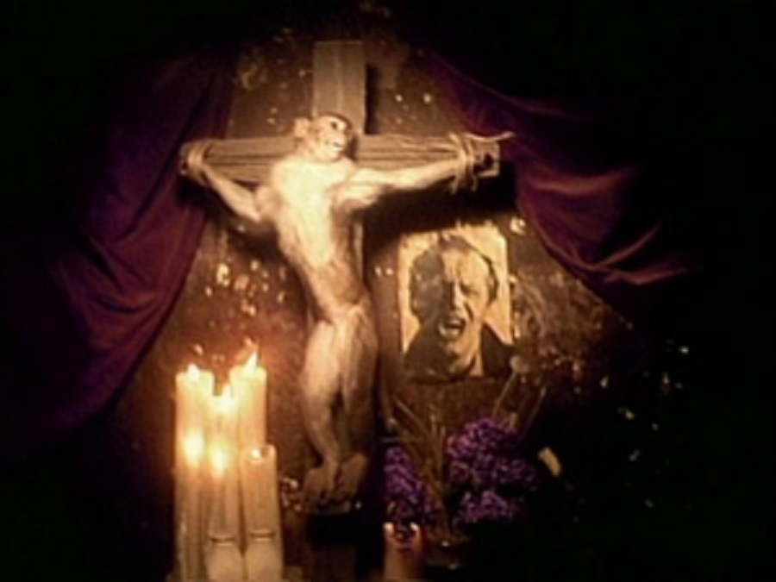



Paul (<:) Jesus first!
www.Alemattec.com

